Application for School Transport Assistance FORM X78
Complete in BLOCK CAPITALS and use black ink (guidance notes overleaf). Please answer all relevant questions
Please note that you can also apply online. To apply online go to www.derbyshire.gov.uk/get2school
Section A
1. Surname of pupil

First name of pupil
Sex (M/F) Date of Birth D D M M Y Y Y Y

Does your child have a Statement of Special Educational Needs? YES / NO

Name of parent/carer

Title: Mr/Mrs/Miss/Ms Other

Child’s home address
For office use
Record Type

Application Date
Start Date
End Date
Eligibility
Post code (essential)

Email address
Telephone Number
Sibling
Transport: Bus / Rail
2. Name of School/College/Establishment (to which transport is required)
Date of Admission
Is this your first application for transport to this school?
3. If this application is made following a change of address, state previous address
When did you move from this address?
Name of school attended when at this address.
D
M
M
Y
Y
Y
Y
Free Transport
Free Transport approved - initials
Approved
4. State the full name of any brother or sister of the child named on this form
who attends the same school and receives a travel pass.
OP
Route

5. If you are applying for home to school transport assistance because you are in
receipt of benefit, please complete the additional section overleaf (Section B)

Please note all applicants need to sign and date the declaration (Section C) overleaf

CONTROLLED
Page 1
Boarding
Alighting
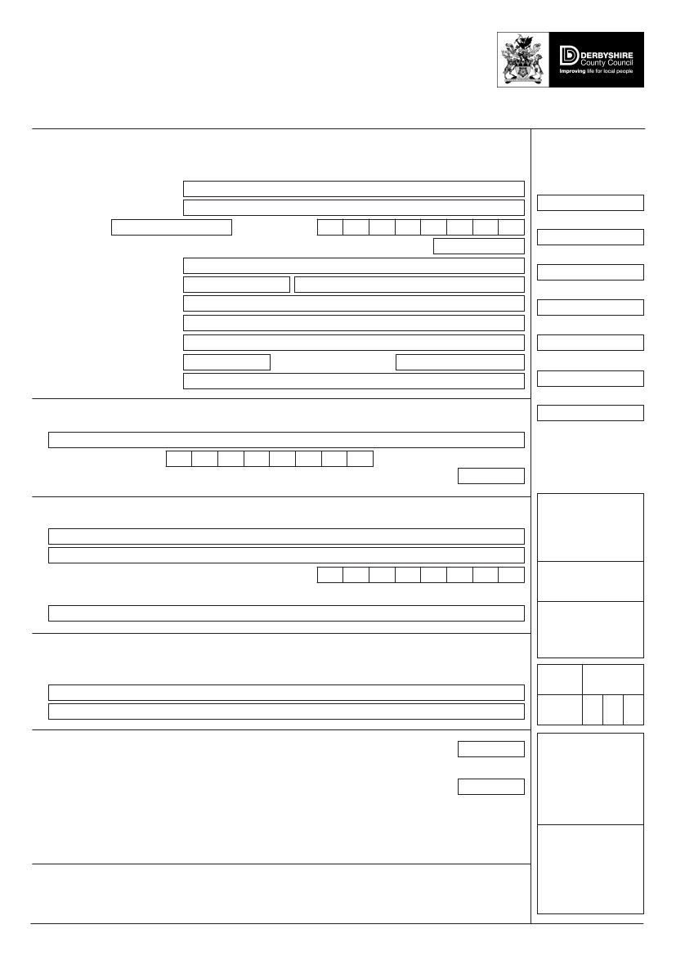
Students transferring from Year 6 to a secondary school will be automatically assessed for eligibility for home to school transport and notified by 30 April.
Parents/carers who have not received confirmation by this date please apply.

Date
Date

Section B

APPLICATION FOR HOME TO SCHOOL TRANSPORT BECAUSE YOU ARE IN RECEIPT OF BENEFIT

Primary Age Pupils
I wish to apply for transport to the school named in Question 2 which is the
nearest suitable school and over two miles from our home address.
Secondary Age Pupils

I wish to apply for transport to the school named in Question 2 which is one of the three nearest suitable schools within 2 to 6 miles from our home address.

I wish to apply for transport to the school named in Question 2 as the nearest school within 2 to 15 miles of our home address, preferred on the grounds of our religion / philosophical beliefs (you must provide supporting written evidence as to why and how the school meets your religious or philosophical beliefs).

Benefit related School Transport Assistance
Please note that transport assistance will only be provided whilst you are in receipt of qualifying benefits. Transport assistance cannot, therefore, be guaranteed for the entire period of attendance at the school. As Working Tax Credit is an annual award, families receiving assistance on this basis will need to reapply each year. Please indicate if this is a renewal application.

Reason why transport is required (see back of form for benefit related guidance)
Please tick appropriate boxes and attach any supporting evidence as details.

I am registered with the Authority / School as eligible for free school meals (we will check relevant records to confirm that this is the case).

I am in receipt of the maximum level of Working Tax Credit and enclose a copy of my latest Tax Credit Award Notice (form TC602) or a letter from the benefits agency confirming current receipt of maximum Working Tax Credit – if this is not enclosed, your application will be refused.

National Insurance Number

SECTION C
DECLARATION AND SIGNATURE OF APPLICANT
I certify that I have parental responsibility for the child named and that the information given is true to the best of my knowledge. I understand that any false or deliberately misleading information given on this form or in support of my application may render this application invalid and could lead to the withdrawal of transport assistance. I agree to notify the Authority of any change in address, benefit entitlement or any other circumstances which might affect transport eligibility.

SIGNATURE…………………………………………………………….. DATE …………………….
‘Privacy Notice: The information you release to us will be used for school transport related purposes and may be shared, as the law allows, with partner organisations. Further details on the Authority’s Data Privacy policies and those of partner organisations can be found on the Derbyshire County Council Website www.derbyshire.gov.uk/privacynotices, or a hard copy can be provided on request.

Page 2

TRANSPORT POLICY.

To the normal area school

The Authority provides assistance with transport for full time primary and secondary school pupils to the
end of statutory school age who do not live within walking distance of their normal area school. This distance is defined in statute as two miles for children under the age of eight and three miles for children over the age of eight.

In all cases, the distance between home and school is measured by the shortest available route. Bus passes or refunds are issued where appropriate and special contract transport is arranged if public transport is not available.

To Faith schools

The Authority no longer provides a transport subsidy to faith schools. However, it will continue to have a duty to provide assistance to those families who meet the criteria for income assessed transport. Please see Section B above and, for further information, please see the Authority’s Transport Policy for Children and Young People at www.derbyshire.gov.uk/get2school.

To other schools

Parents who send their children to a school which is not their normal area school will not normally
receive assistance with transport (children living outside the County attending Derbyshire schools should apply to their home Council). However, assistance with transport will be provided when a child attends a school, other than the normal area school, which is beyond the walking distance explained above but is closer to the child’s home than the normal area school.

Transport for pupils with special educational needs and/or disabilities

Transport will be provided for pupils with special educational needs and/or disabilities who attend their
nearest school, where the journey exceeds the statutory walking distances as outlined above or in other
cases in accordance with the Council’s Special Educational Needs Transport policy.
Provision of transport will not generally be made if the preferred school is further away from the child’s
home than another school considered appropriate by the Council. For more information please refer to
the Authority’s Special Educational Needs Transport Policy available on the Council’s website
www.derbyshire.gov.uk.
Please contact the Special Needs Section at County Hall, Matlock, DE4 3AG (Tel: 01629 536531), if you
have any queries.

Page 3

GUIDANCE CRITERIA FOR BENEFIT RELATED HOME TO SCHOOL TRANSPORT

Children of primary age who are entitled to free school meals or whose families get the maximum level of Working Tax Credit are entitled to free transport to the nearest suitable school where the distance from home is more than two miles.

If your child is of secondary school age (aged 11 to 16, school year 7 to 11) and you are either:

Eligible and registered for free school meals or receiving the maximum level of Working Tax Credit, your child will have an additional entitlement to transport to either:

One of the three nearest suitable schools to where you live that is between 2 and 6 miles from your home
or
The nearest school that is between 2 and 15 miles from home, preferred on the grounds of the parent’s religious or philosophical beliefs. Evidence to support religious or philosophical belief will be required.

Road routes will be used for any distance measurements over 3 miles linked to benefit entitlement.

A copy of your latest Tax Credit Award Notice (form TC602) or a recent letter from the benefits agency confirming receipt of maximum Working Tax Credit will be required in all cases.

What type of transport assistance may be offered?
Normally either a travel pass for public transport / contract vehicle hired by the Authority or the payment of travelling expenses. The Authority will decide the type of transport assistance offered. In general, pupils eligible for transport assistance may be required to walk up to one mile to or from a designated pick up / drop off point.

Further details of the Authority’s Transport Policy are available at www.derbyshire.gov.uk/get2school, or in the parents information booklet – “How to apply for a place at a secondary / primary school – a guide for parents” copies of which are available on Derbyshire’s website www.derbyshire.gov.uk/admissions, or from The School Admissions and Transport Team – see below

Behaviour policy
The Authority has a school transport code of good practice. Children should behave properly at all times.
It is an offence for anyone to misbehave on school transport, or to do anything which would put at risk
the driver or other passengers. Children who create nuisance or cause any damage on school transport
may have their transport provision withdrawn.

ENQUIRIES AND REVIEWS
Any queries about school or college transport should be made to The School Admissions and Transport Team below or by email to admissions.transport@derbyshire.gov.uk.

Please return the completed form to:

Derbyshire County Council, School Admissions and Transport Team, School Road, Off Sheffield Road, Chesterfield, Derbyshire, S41 8LJ Telephone 01629 537499

Page 4

